Spring Integration

Background
Method of thinking software production as set of events and messages instead of service-oriented.

Spring Integration offers a lightwight, noninvasive, and declarative model for constructing message-driven applications.

To understand SI read: Enterprise Integration Patterns.

The patterns are what SI supports, the Spring programming model is how it supports them.

Spring Integration consists of two parts: messaging framework and adapter-based platform that supports flexible integration of applications across the enterprise.

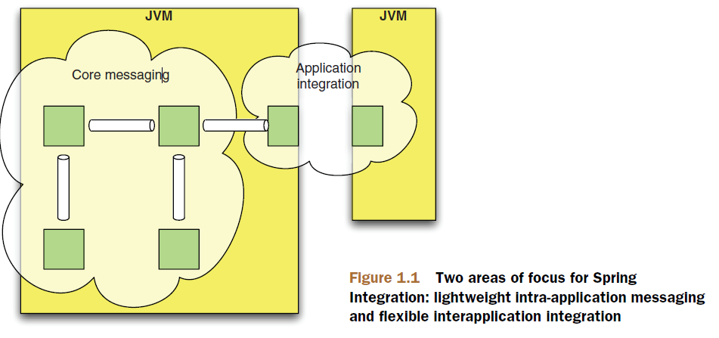

NOTE: inbound=source; outbound=target

SI helps us to apply universally applicable characteristics of good software design: low coupling and high cohesion.

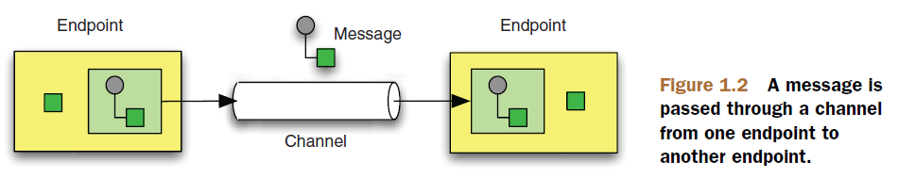
Messages
A message is a unit of information that can be passed between different components, called message endpoints.

Each message consists of headers and a payload. The header contains data that's relevant to the messaging system, such as the Return Address or Correlation ID. The payload contains the actual data to be accessed or processed by the receiver.

Messages Channels
The message channel is the connection between multiple endpoints. The channel implementation manages the details of how and where a message is delivered but shouldn't need to interact with the payload of a message.
Channels may be classified according to whether messages are point-to-point or publish-subscribe.

Message endpoints
Message endpoints are the components that actually do something with the message. This can be as simple as routing to another channel or as complicated as splitting the message into multiple parts or aggregating the parts back together. Connections to the application or the outside world are also endpoints, and these connections take the form of channel adapters, messaging gateways, or service activators.

Hello Spring Integration
Spring Integration aims to provide a clear line between code and configuration.
The components provided by the framework, which often represent the enterprise integration patterns, are typically configured in a declarative way using either XML or Java annotations as metadata. But many of those components act as stereotypes or templates. They play a role that's undestood by the framework, but they require a reference to some user-defined, domain-specific behavior in order to fulfill that role.

Messaging
With Spring Integration, messages aer exchanged through channels between designated endpoints of application components as well as external systems.

NOTE: Message is a pattern!!!

Besides the application data, which is destined to be consumed by the recipient, a message usually packs meta-information. The meta-information is of no interest to the application per se, but it's critical for allowing the infrastructure to handle the information correctly. We call this meta-information message headers.

Types of messages:
- Document msg
- Command msg
- Event msg

A message is a generic wrapper around data that's transported between the different components of the system. The wrapper allows the framework to ignore the type of the content and to treat all messages in the same way when dealing with dispaching and routing.

Channels
Channels are like mailing system!!!!
One distinctive trait of Spring Integration, which differentiates it from other enterprise integration frameworks, is its emphasis on the role of channels in defining the enterprise integration strategy. Channels aren't just information transfer components; they play an active role in defining the overall application behavior. The business processing takes place in the endpoints, but you can alter the channel configuration to completerly change the runtime characteristics of the application.

